A picture containing clipart

Description generated with very high confidence

Azure 103 Module 6

Hands On - 1

Azure Certification Training

[**support@intellipaat.com**](mailto:support@intellipaat.com)

**+91-7022374614**

**US: 1-800-216-8930(Toll Free)**

**Azure 103, Module 6, Hands On - 1**

**Create a custom role for Azure Resources**

**Problem Statement: Create a custom role using Azure CLI.**

**Solution:**

**Step 1:** Go tothe following link and copy the custom role example JSON template and create a JSON file with this code. Name this file as myrole.json.

<https://docs.microsoft.com/en-us/azure/role-based-access-control/tutorial-custom-role-cli#create-a-custom-role>

**Note:** we will edit this JSON template and define our own custom role with its custom permissions. The custom role that we will create will be called Virtual Machine operator. This role will allow the user to start, stop or monitor VMs.

**Step 2:** Open your JSON file in an editor, in name field, provide the name of your custom role that is “Virtual machine Operator” in our demo.

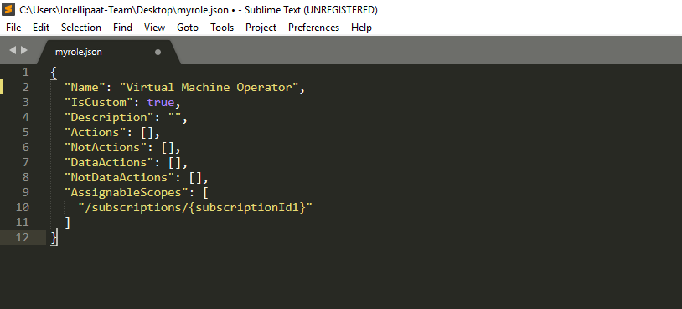

**Step 3:** In Description field, give the description for your custom role, which is in our demo is, can monitor and restart virtual machines.

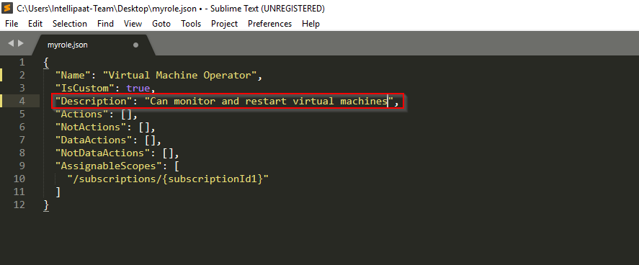

**Step 4:** In Actions field you define the operations that this role is allowed to do. Ass the followinng information in your actions field.

"Microsoft.Storage/*/read",

"Microsoft.Network/*/read",

"Microsoft.Compute/*/read",

"Microsoft.Compute/virtualMachines/start/action",

"Microsoft.Compute/virtualMachines/restart/action",

"Microsoft.Authorization/*/read",

"Microsoft.ResourceHealth/availabilityStatuses/read",

"Microsoft.Resources/subscriptions/resourceGroups/read",

"Microsoft.Insights/alertRules/*",

"Microsoft.Insights/diagnosticSettings/*",

"Microsoft.Support/*"

To learn about more actions that can be used, visit the following link:

<https://docs.microsoft.com/en-us/azure/role-based-access-control/resource-provider-operations#microsoftcompute>

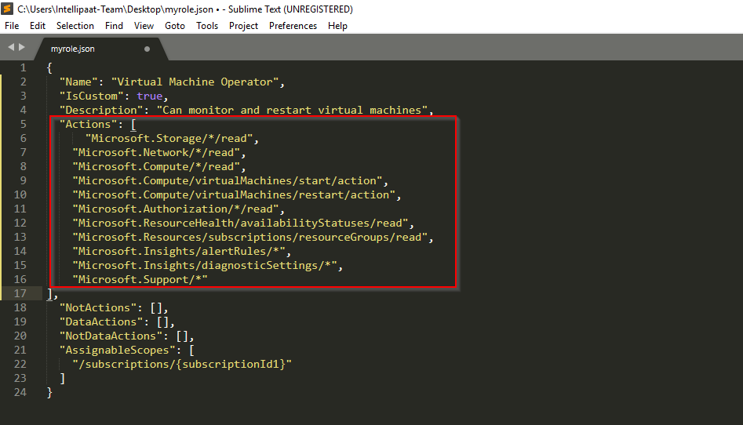

**Step 5:** In assignable scopes field you have to provide your subscription id. You can get the subscription ID using the following command in your CLI (launch CLI from your portal).

**az account list --output table**

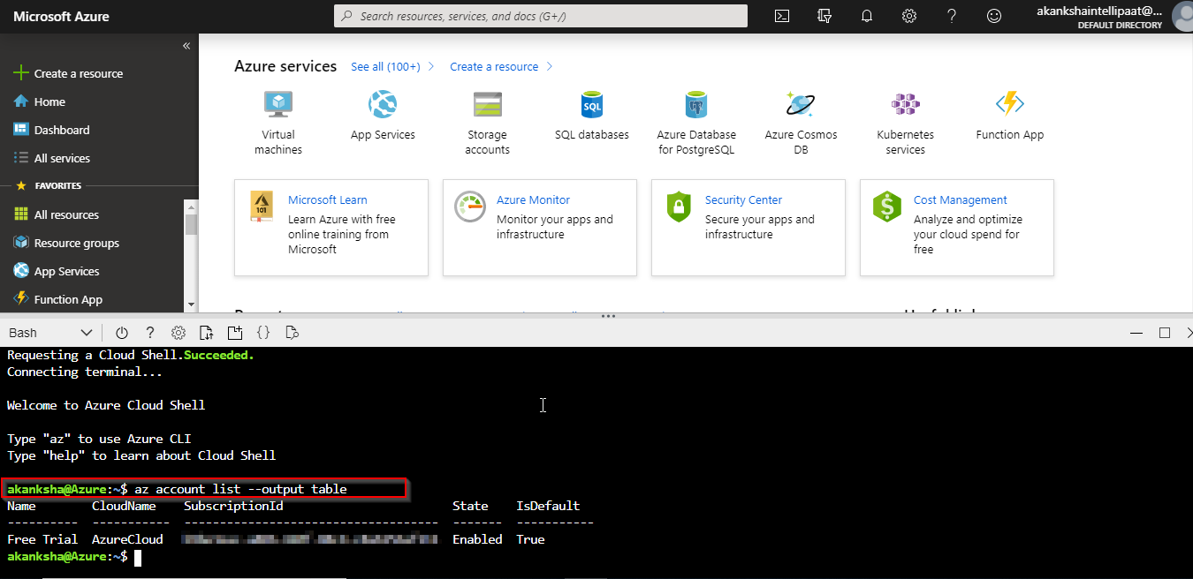

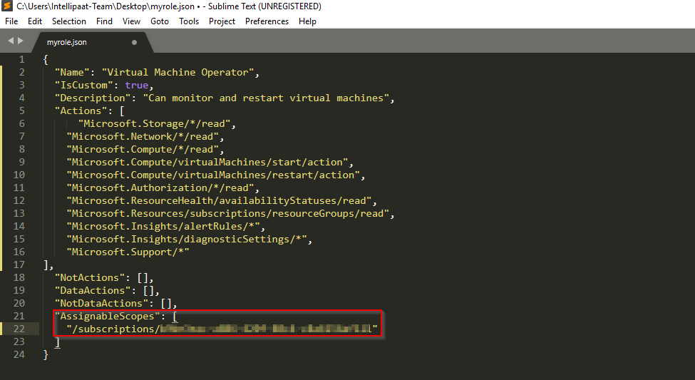

**Step 6:** Save all the changes made to the JSON file**.** Go toAzure CLI and run the following command to create the custom role.

az role definition update --role-definition 'JSON script'

Note: replace JSN script with your myrole JSON script as shown in the following screenshot.

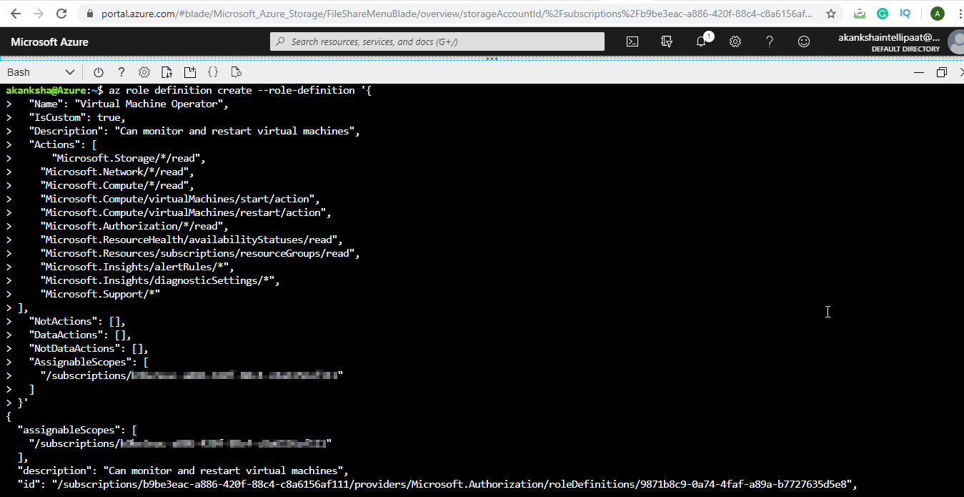

**The new custom role is now available and can be assigned to users, groups, or service principals just like built-in roles.**